Classic Cars Mobile Application

John Doherty B00045141

Jeff Farnan B00045605

# Abstract

The aim of the project is to build a professional mobile application using the desktop application that was we were given for assignment 1. We decided to use Jeff's desktop application which was a website for a company that restored classic cars. The application will have to will have to be a scaled down version in a way because it is not possible to have the same amount of content in a mobile application. The application will have to provide interactive engagement with its users however and also meet the needs of the user. The audience for this particular application will be people with an interest in classic and vintage cars and the application will provide them with information about restoring classic cars and also provide them with information about classic cars.

# Project Description

The technology used in this application are HTML, CSS, Javascript, XML, Json and Jquery for mobile. The application includes headers, footers, navigation bars and buttons. The application will also include a Json feed for You tube videos which will be displayed in a grid format on a video page. There will also be a photo page that will include a Json feed from Flickr. A google map will also be included that gives exact directions from any location to the garage.

# Design

The design of the mobile application had to differ from the design of the desktop application because when you use a mobile application you mostly have to click on buttons or items with your finger which differs to a desktop application as you mostly use a cursor to click on a button or item. It is not practical to put as much content on the mobile application as the user there cannot be as many buttons or widgets because the user is using their finger to press buttons pictures etc. This means that the buttons also have to be bigger because it would be impossible for the user to use navigation bars buttons if they were too small this is something you would not have to consider in a desktop application because the user utilizes the cursor to do these things. The main things that are important when designing it are that it is aesthetically appealing and that it is responsive so that the user can navigate pages and different functions quickly. The screen can also be rotated in mobile device so when designing the application this has to be taken into account another thing that has to be taken into account is that you would have limited CPU and memory resources in a mobile device compared to the more powerful desktop/laptop.

## Home page

The home page consists of a background of classic cars which are in a grid format and there are multi coloured. The garages logo is on the top of the page and it is a dark green underneath this are the navigation bars which are light green and when pressed take you to the other pages.

fig 1

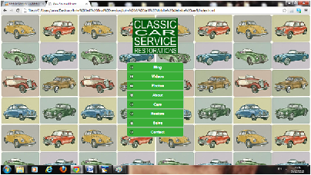

## Blog Page

The blog page consists of a blog which gives lots of information about classic and vintage cars there is an icon in the top left of the screen that brings you back to the home page. There is a footer at the bottom of the page which can bring you to any of the pages in the application. The colour of the background is white and the header at the top of the page is dark green while the name of the page is white in colour. The footer at the bottom of the page is dark green also with the manes of each page in white. The text in the middle of the page is green and the headers for each article are in red.

fig 2

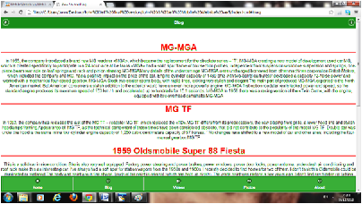

## Photo Page

The photo page consists of a couple of pictures of classic cars that have been restored these pictures are enlarged when they are clicked the colours of the page, header and footer are the same as the blog page except when the picture is clicked and the picture enlarges the background turns black. There is an icon in the top left of the page that brings you to the home page and an icon in the top right of the screen that gives you information about the page.

fig3

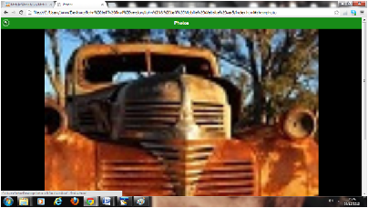

## Video Page

The video page has the same styling as the blog and photo page the background footers and headers are the same colour. It consists of You tube videos which are in a grid format. When the one of the videos are clicked on a video is played on the full screen.

fig 4

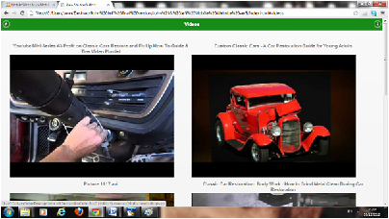

## About Page

The about page has the same styling as the blog page it gives details about the garage its location and opening hours. There is also a Google map on this page that gives you directions from anywhere in the country and the UK to the garage.

fig 5

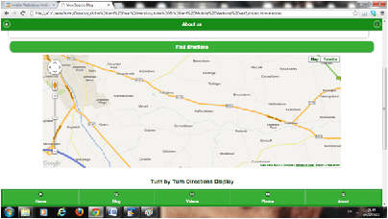

## Cars Page

The car page has the same styling as the previous pages this page consists of some muscle classic cars and has a picture and a description of each one.

fig 6

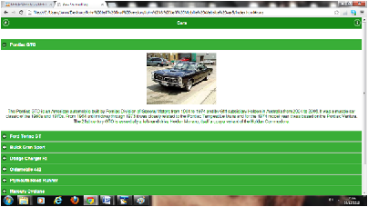

## Restore Page

The restore page has the same styling as the previous page with information on vehicles that were restored and some pictures of the vehicles.

fig 6

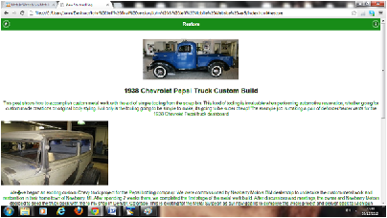

## Sales Page

The sales page has the same styling again as the previous page and it also contains pictures of the cars that the garage is selling.

fig7

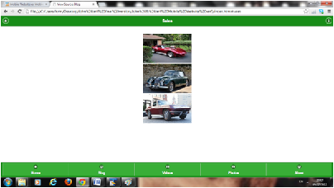

## Contact Page

The contact page also has the same styling as the previous pages and the user can enter his or her details and add some comments they want the owners to see.

fig8

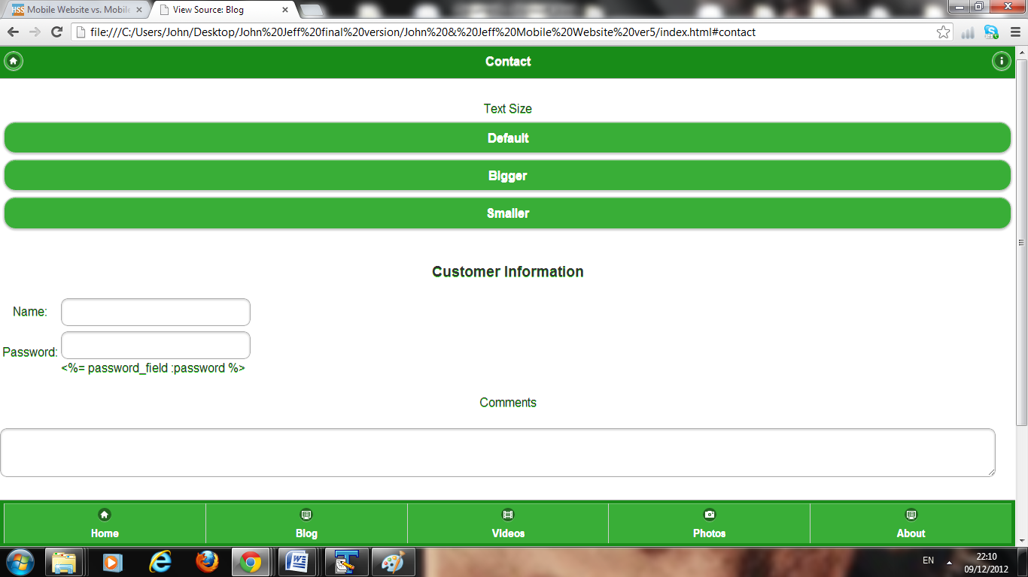

# Conclusion

There were a lot of things learned from this project like the difference between designing a desktop application and a mobile application and the differences between building them. A lot of the features we used in the desktop application could simply not be used in the mobile application. There are things you have to take in to consideration when building a mobile application like the size of the screen and the fact that the screen can be rotated. The browser capability is not as powerful in a mobile device and also the CPU are not as powerful. In doing this project we learned a lot of things about building mobile applications and these will be handy skills for the future because this applications are growing in popularity all the time and with mobile devices becoming more powerful the need for mobile applications are increasing.